- Program to Find the Smallest and largest number in an array Aim: To write a Python program to find the smallest and largest element in an array. Algorithm:

Method 1: Using Iteration.
- Take a variable say mini to store the minimum element of the array and maxi to store the maximum element.
- Set mini = arr[0] and maxi = arr[0]
- Run a loop over the array
- Check if(arr[i]maxi) then set maxi = arr[i]
- After completion of iteration process, print mini and maxi values in an array.

Method 2: Using Sort () function.
- Sort the array using inbuilt sort()function
- Minimum element is at index 0 and maximum is at index -1
- Then, print(arr[0]) and print(arr[-1])

Method 3: Using max () and min () function Method
- Using inbuilt function min(arr) , it return minimum element of the array.
- Similarly max(arr) return the maximum element of the array.

Method 4: Inputs given at run time #Initialize array
arr = []; temp = 0;
noofelements =int(input("Enter the elements to be inserted in an array: ")) ; for i in range(0, noofelements):
x=i+1
value = int(input("Please enter the Value of Element %d : " %x)) arr.append(value)

#Displaying elements of original array
print("Elements Stored in an array: ");
for i in range(0, noofelements): print(arr[i], end=" "); print(); #Smallest Element in an array temp=arr[0] for i in range(1, len(arr)):
if(temp < arr[i]):

else:
temp = temp;

temp=arr[i];

print("Smallest Element in an array: " ,temp) print();

#Largest Element in an array
temp=arr[0]
for i in range(1, len(arr)): if(temp > arr[i]):
temp = temp;
else:
temp=arr[i];
print("Largest Element in an array: " ,temp) print();

Program:
Method 1: Using Iteration.
arr = [10, 89, 9, 56, 4, 80, 8]
mini = arr[0] maxi = arr[0]
for i in range(len(arr)):
if arr[i] < mini: mini = arr[i] if arr[i] > maxi: maxi = arr[i] print ('array elements:',arr)
print ('smallest element in an array:',mini) print ('largest element in an array:',maxi)

Method 2: Using Sort () function.
arr = [10, 89, 9, 56, 4, 80, 8]
print ('Array Elements:',arr) arr.sort()
print ('smallest element in an array:',arr[0]) print ('Largest element in an array:',arr[-1])

Method 3: Using max () and min () function Method
arr = [10, 89, 9, 56, 4, 80, 8]
print ('Array Elements:',arr)

print ('smallest element in an array:',min(arr)) print ('Largest element in an array:',max(arr))

Method 4: Inputs given at run time
arr = []
n = int(input("enter size of array : ")) for x in range(n):
x=int(input("enter element of array : ")) arr.append(x)
largest = arr[0] smallest = arr[0] for i in range(n):
if arr[i]>largest: largest = arr[i]
if arr[i]<smallest: smallest = arr[i]
print(‘Array Elements:’,arr)
print(f"Largest element in array is {largest}") print(f"Smallest element in array is {smallest}")

Sample Input/Output:
Method 1:
array elements: [10, 89, 9, 56, 4, 80, 8] smallest element in an array: 4
largest element in an array: 89

Method 2:
Array Elements: [10, 89, 9, 56, 4, 80, 8] smallest element in an array: 4
Largest element in an array: 89

Method 3:
Array Elements: [10, 89, 9, 56, 4, 80, 8] smallest element in an array: 4

Largest element in an array: 89

Method 4:
enter size of array : 5 enter element of array : 87 enter element of array : 23 enter element of array : 9 enter element of array : 2 enter element of array : 76
Array Elements: [87, 23, 9, 2, 76] Largest element in array is 87 Smallest element in array is 2

Flow Chart:

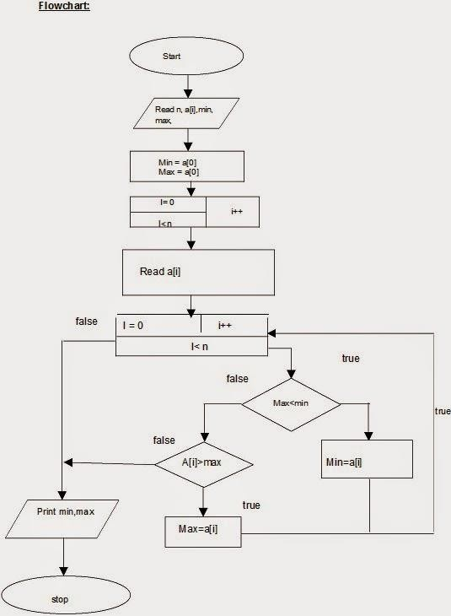
Result:
Thus the program is successfully executed and outputs are verified.

- Program to implement operations on a Singly linked list Aim: To write a Python program to implement operations on a singly linked list Algorithm:

Creation of Node:
  - Create a class Node which has two attributes: data and next. Next is a pointer to the next node.
  - Create another class which has two attributes: head and tail.
  - addNode() will add a new node to the list:
    - Create a new node.
    - It first checks, whether the head is equal to null which means the list is empty.
    - If the list is empty, both head and tail will point to the newly added node.
    - If the list is not empty, the new node will be added to end of the list such that tail's next will point to the newly added node. This new node will become the new tail of the list.

Insertion Operation: Insert item at the head
  - Create a new node. Insert the item in the data field of the node.
  - Set the new node’s next pointer to the node current head is pointing to.
  - Make the head pointer point to the newly added node.

Insert an item at the end

- Seek through the list until the final node is reached.
- Create a new node using the item to be inserted.
- Set the last node’s next pointer to the newly created node.
- Set the next pointer of the new node to null.

Insert item after another item (To insert an item anywhere between the first and the last node)

- Seek through the list until the desired node N (after which you want to insert the new node) is found.
- Create a new node using the item to be inserted.
- Set the new node’s next pointer to the node N.
- Set N’s next pointer to the newly created node.

Deletion Operation: Delete item at the head
  - Set the next pointer of the first node to null.
  - Move the current head of the list to the second node.
  - Delete the first node.

Delete item at the end

- Seek through the list until you get to the last node (You might need to keep track of the previous node as well).
- Set the previous node’s next to null.
- Delete the last node.

Delete item anywhere in the list

- Search the list element until find the item you are looking for. Let’s call this node N.
- Set N’s previous node’s next to the N’s next node’s next.
- Delete N.

Searching an item in the list
- Start with the head. Make head as the current node.
- Run a loop until the current node is NULL because the last element points to NULL.
- In each iteration, check if the key of the node is equal to item. If it the key matches the item, return true otherwise return false.
- Display Operation:
  - Define a node current which initially points to the head of the list.
  - Traverse through the list till current points to null.
  - Display each node by making current to point to node next to it in each iteration.

Program:
# Linked list operations in Python

# Create a node
class Node:
def init (self, data): self.data = data self.next = None
class LinkedList: def init (self):
self.head = None

# Insert at the beginning
def insertAtBeginning(self, new_data): new_node = Node(new_data) new_node.next = self.head self.head = new_node

# Insert after a node
def insertAfter(self, prev_node, new_data): if prev_node is None:
print("The given previous node must inLinkedList.") return
new_node = Node(new_data) new_node.next = prev_node.next prev_node.next = new_node

# Insert at the end
def insertAtEnd(self, new_data): new_node = Node(new_data) if self.head is None:
self.head = new_node return

last = self.head while (last.next):
last = last.next last.next = new_node

# Deleting a node
def deleteNode(self, position): if self.head is None:
return
temp = self.head if position == 0:
self.head = temp.next temp = None
return

# Find the key to be deleted
for i in range(position - 1): temp = temp.next
if temp is None: break
# If the key is not present if temp is None:
return
if temp.next is None: return
next = temp.next.next temp.next = None temp.next = next

# Search an element
def search(self, key): current = self.head

while current is not None: if current.data == key:
return True
current = current.next return False

# Print the linked list
def printList(self): temp = self.head while (temp):
print(str(temp.data) + " ", end="") temp = temp.next
if name == ' main ': llist = LinkedList() llist.insertAtEnd(1) llist.insertAtBeginning(2) llist.insertAtBeginning(3) llist.insertAtEnd(4)
llist.insertAfter(llist.head.next, 5)

print (‘Singly Linked List’) print('linked list:') llist.printList()

print("\nAfter deleting an element:") llist.deleteNode(3)
llist.printList()

print() item_to_find = 3
if llist.search(item_to_find): print(str(item_to_find) + " is found")

else:
print(str(item_to_find) + " is not found")

llist.sortLinkedList(llist.head) print("Sorted List: ") llist.printList()

FlowChart:

Result: Thus the program has been successfully executed and output verified.

3. Program to implement operations on a doubly linked list Aim: To write a Python program to implement operations on a doubly linked list Algorithm:
- Create a class Node with instance variables data and next.
- Create a class DoublyLinkedList with instance variables first and last.
- The variable first points to the first element in the doubly linked list while last points to the last element.
- Define methods get_node, insert_first, insert_mid, insert_last, delete_first, de- lete_mid, delete_last for insertion , remove and display.
- get_node takes an index as argument and traverses the list from the first node that many times to return the node at that index.
- The methods insert_after and insert_before insert a node after or before some reference node in the list.
- The methods insert_at_beg and insert_at_end insert a node at the first or last position of the list.
- The method remove takes a node as argument and removes it from the list.
- The method display traverses the list from the first node and prints the data of each node.
- Create an instance of DoublyLinkedList and present the user with a menu to perform operations on the list.

Program:
class Node:
def init (self,data): self.data = data self.next = None self.prev= None

class Linked_list: def init (self):
self.head = None

def list(self,data): newnode = Node(data) newnode.next=None newnode.prev=None

if self.head is None: self.head = newnode return
temp = self.head while temp.next:
temp=temp.next temp.next = newnode

def insert_first(self,data): newnode = Node(data) if self.head is None:
self.head=newnode return
else:
#temp=self.head self.head.prev=newnode newnode.next=self.head self.head=newnode

def insert_mid(self,data,pos): newnode=Node(data)
if self.head is None: self.head=newnode return
else:

temp=self.head i=1
while(i<(pos-1)): temp=temp.next i=i+1

newnode.next=temp.next temp.next=newnode temp.next.prev=newnode newnode.prev=temp

def insert_last(self,data): newnode=Node(data) if self.head is None:
self.head=newnode return
else:
temp=self.head while temp.next:
temp=temp.next temp.next = newnode newnode.prev=temp

def delete_first(self):
if self.head is None: print("list is empty") #temp=self.head
else:
self.head=self.head.next self.head.prev=None

def delete_mid(self,pos): if self.head is None:
print("list is empty") else:
temp=self.head i=1 while(i<(pos)):
p=temp temp=temp.next i=i+1
p.next=temp.next temp.next.prev=p

def delete_last(self):
if self.head is None: print("list is empty")
else:
temp=self.head while temp.next:
pre=temp temp=temp.next
pre.next=None

def display(self):
if self.head is None: #print("list is empty") return
else:
temp = self.head #h=hex(id(self.head))

#print(int(h,0),"<-->") while temp is not None:
d=hex(id(temp.next)) print(temp.data,"<-->", end=' ') temp = temp.next

LL=Linked_list() print(‘Doubly Linked list’)
print("\n1.Create\n2.Insert_First\n3.Insert_Middle\n4.Insert_Last\n5.Delete_First\n6. Delete_Middle\n7.DeleteLast\n8.Exit")
while(True):
choice=int(input("\nenter the choice")) if choice==1:
a=int(input("\nenter the node value")) LL.list(a)
LL.display() elif choice==2:
b=int(input("\nenter the node value insert at first")) LL.insert_first(b)
LL.display() elif choice==3:
pos=int(input("\nenter the position")) c=int(input("\nenter the node value insert at middle")) LL.insert_mid(c,pos)
LL.display() elif choice==4:
d=int(input("\nenter the node value insert at last")) LL.insert_last(d)
LL.display() elif choice==5:
LL.delete_first()

LL.display() elif choice==6:
pos=int(input("\nenter the position to delete")) LL.delete_mid(pos)
LL.display() elif choice==7:
LL.delete_last() LL.display()
else:
print("\nno choice") break

Sample Input and Output:
Doubly Linked list 1.Create 2.Insert_First 3.Insert_Middle 4.Insert_Last 5.Delete_First 6.Delete_Middle 7.DeleteLast 8.Exit
enter the choice1 enter the node value67 67 <-->
enter the choice1 enter the node value23 67 <--> 23 <-->
enter the choice1 enter the node value45 67 <--> 23 <--> 45 <-->
enter the choice2

enter the node value insert at first3 3 <--> 67 <--> 23 <--> 45 <-->
enter the choice3 enter the position:3
enter the node value insert at middle78 3 <--> 67 <--> 78 <--> 23 <--> 45 <-->
enter the choice4
enter the node value insert at last90
3 <--> 67 <--> 78 <--> 23 <--> 45 <--> 90 <-->
enter the choice5
67 <--> 78 <--> 23 <--> 45 <--> 90 <-->
enter the choice6
enter the position to delete2
67 <--> 23 <--> 45 <--> 90 <-->
enter the choice7
67 <--> 23 <--> 45 <-->
enter the choice8 no choice:

Flowchart:

Result: Thus the doubly linked list program has successfully executed and outputs are verified.

4. Insertion Sort
Aim:

To write a python program to sort the elements using insertion sort.

Algorithm:

- Get the array elements. To sort an array of size N in ascending order.
- Iterate from arr[1] to arr[n] over the array.
- Take the first element and consider it to be a sorted part
- Now pick arr [1] and and store it is a temporary variable
- Start comparing the values of (temp) temporary with elements of the sorted part from the rear side.
- If temp (temporary element is less than the rear element, arr[k], then shift arr[k] to k+1 index.
- This shifting will continue until the appropriate location is identified. Then, we will put the temporary element at the identified location
- This will continue for all the elements. It will repeat, until to get the desired sorted array in ascending order

Program:
# Insertion sort in Python def insertionSort(array):
for step in range(1, len(array)): key = array[step]
j = step - 1
# Compare key with each element on the left of it until an element smaller than it is found
# For descending order, change key<array[j] to key>array[j]. while j >= 0 and key < array[j]:
array[j + 1] = array[j] j = j - 1
# Place key at after the element just smaller than it. array[j + 1] = key

data = [9, 5, 1, 4, 3]
print(‘Insertion Sort’) print('Array elements:') print(data) insertionSort(data)
print('Sorted Array in Ascending Order:') print(data)

Sample Output
Insertion Sort Array elements:
[9, 5, 1, 4, 3]
Sorted Array in Ascending Order:
[1, 3, 4, 5, 9]

Flow Chart for Insertion Sort

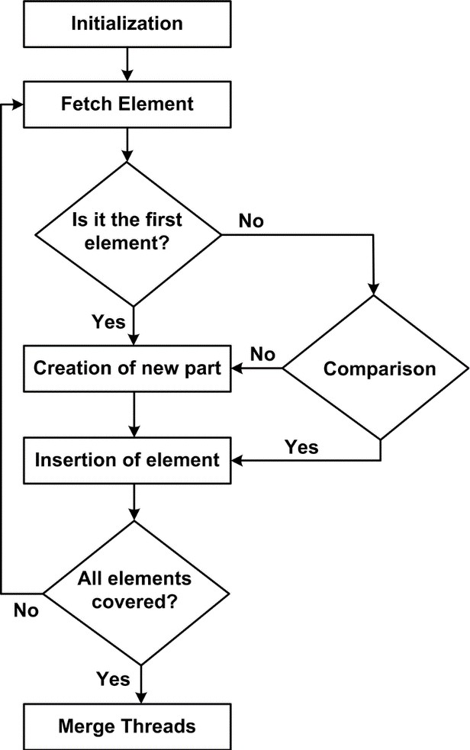
Result: Thus the insertion sort algorithm was successfully executed.

5. Quick Sort

Aim:

To write a python program to sort the elements using quick sort.

Algorithm:

- Choose the highest index value as pivot.
- Take two variables to point left and right of the list excluding pivot.
- Left points to the low index.
- Right points to the high index.
- While value at left < (Less than) pivot move right.
- While value at right > (Greater than) pivot move left.
- If both Step 5 and Step 6 does not match, swap left and right.
- If left = (Less than or Equal to) right, the point where they met is new pivot.

Program:

#Quicksort
def quicksort(alist, start, end):
'''Sorts the list from indexes start to end - 1 inclusive.''' if end - start > 1:
p = partition(alist, start, end) quicksort(alist, start, p) quicksort(alist, p + 1, end)

def partition(alist, start, end): pivot = alist[start]
i = start + 1 j = end - 1

while True:
while (i <= j and alist[i] <= pivot): i = i + 1
while (i <= j and alist[j] >= pivot): j = j - 1

if i <= j:
alist[i], alist[j] = alist[j], alist[i] else:
alist[start], alist[j] = alist[j], alist[start]

return j

print(‘Quick Sort’)
alist = input('Enter the list of numbers: ').split() alist = [int(x) for x in alist]
quicksort(alist, 0, len(alist)) print('Sorted list: ', end='') print(alist)

Sample Output

Quick sort

Enter the list of numbers: 2 3 91 10 1

Sorted list: [1, 2, 3, 10, 91]

Flowchart:

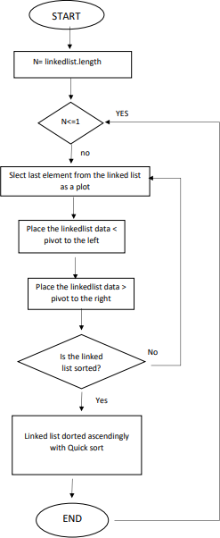

Result: Thus the quick sort algorithm was successfully executed.

6. Merge Sort
Aim:

To write a python program to sort the elements using merge sort.

Algorithm:

  - Create a merge_sort() function
  - Initiate array list and divide it into subarrays.
  - Create copies of the subarrays
  - Create three-pointers that maintain indexes.
  - Pick larger elements and place them in the right position
  - Pick the remaining elements and sort them accordingly
  - The result will be sorted array
  - Print the sorted array.

Program:

def mergeSort(arr): if len(arr) > 1:
# Create sub_array2 ← A[start..mid] and sub_array2 ← A[mid+1..end] mid = len(arr)//2
sub_array1 = arr[:mid] sub_array2 = arr[mid:]
# Sort the two halves mergeSort(sub_array1) mergeSort(sub_array2)
# Initial values for pointers that we use to keep track of where we are in each array i = j = k = 0
# Until we reach the end of either start or end, pick larger among

# elements start and end and place them in the correct position in the sorted array

while i < len(sub_array1) and j < len(sub_array2): if sub_array1[i] < sub_array2[j]:
arr[k] = sub_array1[i] i += 1
else:

arr[k] = sub_array2[j] j += 1
k += 1

# When all elements are traversed in either arr1 or arr2, # pick up the remaining elements and put in sorted array
while i < len(sub_array1): arr[k] = sub_array1[i]
i += 1

k += 1

while j < len(sub_array2): arr[k] = sub_array2[j]
j += 1

k += 1

arr = [10, 9, 2, 4, 6, 13]

print(‘Merge Sort’) print('Unsorted array',arr) mergeSort(arr) print('Sorted array',arr)

Sample Input/Output:

Merge Sort

Unsorted array [10, 9, 2, 4, 6, 13]

Sorted array [2, 4, 6, 9, 10, 13]

Flowchart:
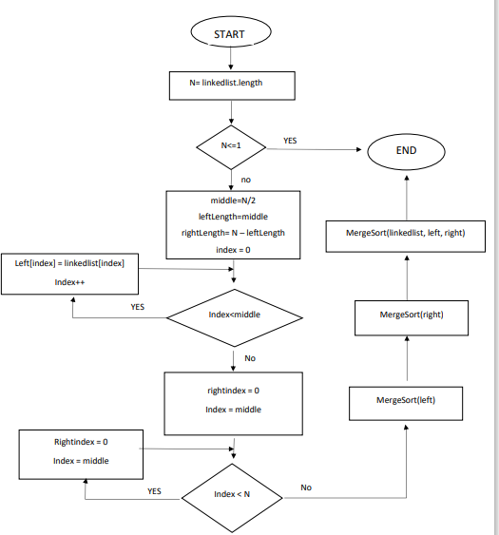

Result: Thus the merge sort algorithm was successfully executed.

7. Implement Stack using an array and Linked List

AIM:
To write a python program to implement a Stack using an array and Linked list.

Algorithm:
- Create a class Stack with instance variable items initialized to an empty list
- Define methods push, pop and is_empty inside the class Stack.
- The method push appends data to items.
- The method pop pops the first element in items.
- The method is_empty returns True only if items is empty.
- Create an instance of Stack and present a menu to the user to perform operations on the stack.
Push Operation:
  - Initialise a node.
  - Update the value of that node by data i.e. node->data = data.
  - Now link this node to the top of the linked list.
  - And update top pointer to the current node. Pop Operation:
  - First Check whether there is any node present in the linked list or not, if not then return.
  - Otherwise make pointer let say temp to the top node and move forward the top node by 1 step.
  - Now free this temp node Peek Operation:
  - Check if there is any node present or not, if not then return.
  - Otherwise return the value of top node of the linked list Display Operation:
  - Take a temp node and initialize it with top pointer.
  - Now start traversing temp till it encounters NULL.
  - Simultaneously print the value of the temp node.

Program:
//To implement a Stack using an array class Stack:
def init (self):
self.items = []
def is_empty(self):
return len(self.items) == 0
def push(self, item):
self.items.append(item)
def pop(self):
if self.is_empty():
return None
return self.items.pop()

def peek(self):
if self.is_empty():
return None
return self.items[-1]
def size(self):
return len(self.items) # Example usage
s = Stack() s.push(1)
s.push(2)
s.push(3)
print(s.size()) # Output: 3 print(s.pop()) # Output: 3 print(s.pop()) # Output: 2 print(s.peek()) # Output: 1 Output:
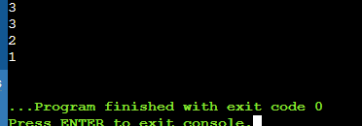

//To implement a Stack using Linked list.
class Node:
# Class to create nodes of linked list def init (self,data):
self.data = data self.next = None
class Stack:
# set the head to NULL def init (self):
self.head = None
# Checks if stack is empty def isempty(self):
if self.head == None: return True
else:
return False
# Method to add data to the stack def push(self,data):
if self.head == None: self.head=Node(data)
else:
newnode = Node(data) newnode.next = self.head self.head = newnode
# Remove element that is the current head def pop(self):
if self.isempty():

return None else:
poppednode = self.head self.head = self.head.next poppednode.next = None print("\nItem popped"); return poppednode.data
# Returns the head node data def peek(self):
if self.isempty(): return None
else:
return self.head.data # Prints out the stack
def display(self): iternode = self.head if self.isempty():
print("Stack Underflow") else:
print("\nPrinting stack elements:") while(iternode != None):
print(iternode.data," ",end = " ") iternode = iternode.next
return # Driver code obj = Stack() obj.push(43) obj.push(12) obj.push(23) obj.push(64)
# Display stack elements obj.display()
# Print top element of stack print("\nTop element: ",obj.peek()) # Delete top elements of stack obj.pop()
obj.pop()
# Display stack elements obj.display()
# Print top element of stack print("\nTop element: ", obj.peek())

Output:

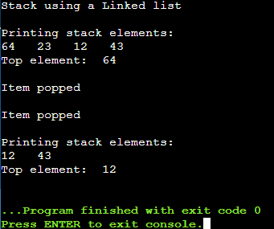

Result:
Thus, the stack is successfully implemented using an array and linked list and output is verified.

8. Program to implementation of Queue using an array and Linked list

Aim: To write a Python program to implementation of queue using an array and linked list.

Algorithm:
To implement a queue using an array,
- create an array arr of size n. Then take two variables front and rear both of which will be initialized to 0 which means the queue is currently empty.
- Element
  - rear is the index up to which the elements are stored in the array and
  - front is the index of the first element of the array.

Front : Returns the FRONT value of queue.
- First to check that queue is not empty.
- If the queue is empty then we display that the queue is empty we simply return from the function and not execute further inside the function
- Otherwise, we will return the FRONT index value.

Enqueue Operation
- If n-1==REAR then this means the queue is already full.
- But if REAR<n means that we can store an element in an array.
- So increment the REAR value by 1 and then insert an element at the REAR index.

Dequeue
- If front == - 1 or front > rear then no element is available to delete.
- Else delete FRONT index element
- If REAR==FRONT then we set -1 to both FRONT AND REAR
- Else we increment FRONT.

Display
It will traverse the queue and print all the elements of the queue.
- Firstly check whether the queue is not empty.
- If empty we display that the queue is empty we simply return from the function and not execute further inside the function.
- Else we will print all elements from FRONT to REAR.
- Stop the program

Program: Implementation of a Queue using an array

class Queue:
# To initialize the object.

def init (self, c):
self.queue = [] self.front = self.rear = 0 self.capacity = c

# Function to insert an element # at the rear of the queue def queueEnqueue(self, data):

# Check queue is full or not if(self.capacity == self.rear):
print("\nQueue is full")

# Insert element at the rear else:
self.queue.append(data) self.rear += 1

# Function to delete an element # from the front of the queue def queueDequeue(self):

# If queue is empty if(self.front == self.rear):
print("Queue is empty")

# Pop the front element from list else:
x = self.queue.pop(0) self.rear -= 1

# Function to print queue elements def queueDisplay(self):

if(self.front == self.rear): print("\nQueue is Empty")

# Traverse front to rear to # print elements
for i in self.queue:
print(i, "<--", end='')

# Print front of queue def queueFront(self):

if(self.front == self.rear): print("\nQueue is Empty")

print("\nFront Element is:", self.queue[self.front])

# Driver code
if name == ' main ':
# Create a new queue of

# capacity 4 q = Queue(4)

# Print queue elements q.queueDisplay()

# Inserting elements in the queue q.queueEnqueue(20) q.queueEnqueue(30) q.queueEnqueue(40) q.queueEnqueue(50)

# Print queue elements q.queueDisplay()

# Insert element in queue q.queueEnqueue(60)

# Print queue elements q.queueDisplay()

q.queueDequeue() q.queueDequeue()
print("\n\nafter two node deletion\n")

# Print queue elements q.queueDisplay()

# Print front of queue q.queueFront()

Output:
Queue is Empty

20 <--30 <--40 <--50 <--

Queue is full

20 <--30 <--40 <--50 <--

after two node deletion 40 <--50 <--
Front Element is:40

Algorithm for Implementation of Queue using an Linked list

  - Create a class Node with instance variables data and next.
  - Create a class Queue with instance variables head and last.
  - The variable head points to the first element in the linked list while last points to the last element.
  - Define methods enqueue and dequeue inside the class Queue.
  - The method enqueue adds a node at the end of the linked list.
  - The method dequeue returns the data of the node at the front of the linked list and removes the node. It returns None if there are no nodes.
  - Create an instance of Queue and present a menu to the user to perform operations on the queue.

Program for Queue using a Linked list:
class Node:
def init (self, data): self.data = data self.next = None

class Queue:
def init (self): self.head = None self.tail = None

def is_empty(self):
return self.head is None

def enqueue(self, item): new_node = Node(item) if self.is_empty():
self.head = new_node self.tail = new_node
else:
self.tail.next = new_node self.tail = new_node

def dequeue(self): if self.is_empty():
return None
item = self.head.data self.head = self.head.next if self.head is None:
self.tail = None return item

def peek(self):
if self.is_empty(): return None
return self.head.data

def size(self):
current = self.head count = 0
while current is not None: count += 1
current = current.next return count

# Example usage q = Queue() q.enqueue(1) q.enqueue(2) q.enqueue(3)
print(q.size()) # Output: 3 print(q.dequeue()) # Output: 1 print(q.dequeue()) # Output: 2 print(q.peek()) # Output: 3

Output:
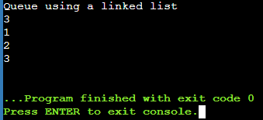
Result:
Thus, the Queue is successfully implemented using an array and linked list and output is verified.

9. Program to implement a Circular Queue

Aim:
To write a Python program to implement a circular queue.

Algorithm for Circular Queue
- Initialize the queue, with size of the queue defined (maxSize), and head and tail pointers.
- enqueue: Check if the number of elements is equal to maxSize - 1:
  - If Yes, then return Queue is full
  - If No, then add the new data element to the location of tail pointer and increment the tail pointer.
- dequeue: Check if the number of elements in the queue is zero:
  - If Yes, then return Queue is empty

  - If No, then increment the head pointer.
- size:
  - If, tail >= head, size = tail - head
  - But if, head > tail, then size = maxSize - (head - tail)
- Front: Get the front item from the queue.
- Rear: Get the last item from the queue.
- Stop the program

Program:
#Circular Queue:
class CircularQueue(): # constructor
def __init__(self, size): # initializing the class
self.size = size

# initializing queue with none self.queue = [None for i in range(size)] self.front = self.rear = -1

def enqueue(self, data):

# condition if queue is full
if ((self.rear + 1) % self.size == self.front): print(" Queue is Full\n")

# condition for empty queue elif (self.front == -1):
self.front = 0
self.rear = 0 self.queue[self.rear] = data
else:

# next position of rear
self.rear = (self.rear + 1) % self.size self.queue[self.rear] = data

def dequeue(self):
if (self.front == -1): # condition for empty queue print ("Queue is Empty\n")

# condition for only one element elif (self.front == self.rear):
temp=self.queue[self.front] self.front = -1
self.rear = -1 return temp
else:
temp = self.queue[self.front]

self.front = (self.front + 1) % self.size return temp

def display(self):

# condition for empty queue if(self.front == -1):
print ("Queue is Empty")

elif (self.rear >= self.front):
print("Elements in the circular queue are:",
end = " ")
for i in range(self.front, self.rear + 1): print(self.queue[i], end = " ")
print ()

else:
print ("Elements in Circular Queue are:",
end = " ")
for i in range(self.front, self.size): print(self.queue[i], end = " ")
for i in range(0, self.rear + 1): print(self.queue[i], end = " ")
print ()

if ((self.rear + 1) % self.size == self.front): print("Queue is Full")

# Driver Code
ob = CircularQueue(5) ob.enqueue(14) ob.enqueue(22) ob.enqueue(13) ob.enqueue(-6) ob.display()
print ("Deleted value = ", ob.dequeue()) print ("Deleted value = ", ob.dequeue()) ob.display()
ob.enqueue(9) ob.enqueue(20) ob.enqueue(5) ob.display()

Sample Input/Output:
Elements in the circular queue are: 14 22 13 -6 Deleted value = 14
Deleted value = 22
Elements in the circular queue are: 13 -6 Elements in Circular Queue are: 13 -6 9 20 5 Queue is Full

Result:

Thus the Circular queue is successfully implemented and output is verified.

10. Program to convert an infix expression to postfix expression

Aim:
To write a Python program to convert an infix expression to postfix expression

Algorithm:
- Scan the infix expression from left to right.
- If the scanned character is an operand, put it in the postfix expression.
- Otherwise, do the following
  - If the precedence and associativity of the scanned operator are greater than the precedence and associativity of the operator in the stack [or the stack is empty or the stack contains a ‘(‘ ], then push it in the stack. [‘^‘ operator is right associative and other operators like ‘+‘,’–‘,’*‘ and ‘/‘ are left-associative].
    - Check especially for a condition when the operator at the top of the stack and the scanned operator both are ‘^‘. In this condition, the precedence of the scanned operator is higher due to its right associativity. So it will be pushed into the operator stack.
    - In all the other cases when the top of the operator stack is the same as the scanned operator, then pop the operator from the stack because of left associativity due to which the scanned operator has less precedence.
  - Else, Pop all the operators from the stack which are greater than or equal to in precedence than that of the scanned operator.
    - After doing that Push the scanned operator to the stack.
- If the scanned character is a ‘(‘, push it to the stack.
- If the scanned character is a ‘)’, pop the stack and output it until a ‘(‘ is encountered, and discard both the parenthesis.

- Repeat steps 2-5 until the infix expression is scanned.

Program:
# convert an infix expression to postfix expression

Operators = set(['+', '-', '*', '/', '(', ')', '^']) # collection of Operators
Priority = {'+':1, '-':1, '*':2, '/':2, '^':3} # dictionary having priorities of Operators
def infixToPostfix(expression):
stack = [] # initialization of empty stack output = ''
for character in expression:
if character not in Operators: # if an operand append in postfix expression output+= character
elif character=='(': # else Operators push onto stack

stack.append('(')

elif character==')':

while stack and stack[-1]!= '(': output+=stack.pop()
stack.pop()

else:

while stack and stack[-1]!='(' and Priority[character]<=Priority[stack[-1]]: output+=stack.pop()
stack.append(character)
while stack: output+=stack.pop()

return output
expression = input('Enter infix expression ')

print('infix notation: ',expression)

print('postfix notation: ',infixToPostfix(expression))

Output:
Enter infix expression m*n+(p-q)+r infix notation: m*n+(p-q)+r
postfix notation: mn*pq-+r+

Flowchart: for infix to postfix expression

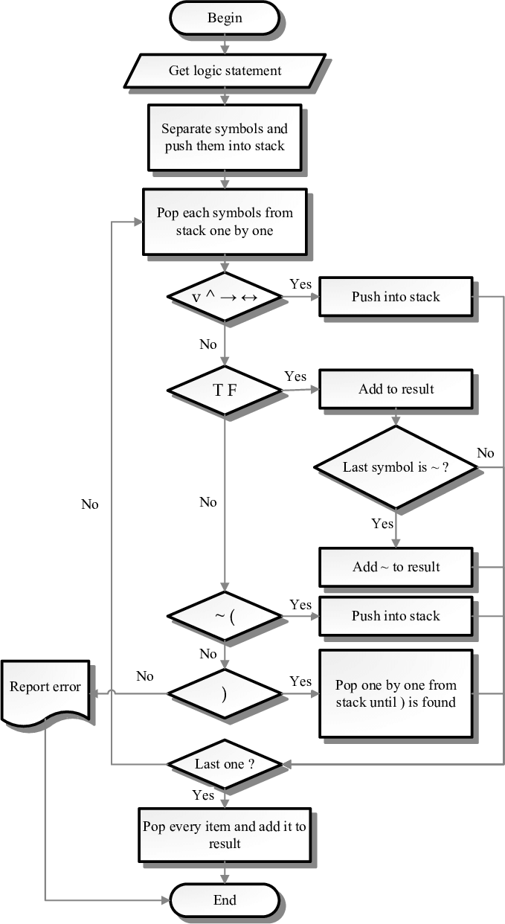

Result:
Thus the infix to postfix expression is successfully implemented and output is verified.

Aim:
11. Program to implement BFS and DFS

To write a Python program to implement the Breadth First Search (BFS) and Depth

First Search (DFS)

Algorithm:
Algorithm for Breadth First Search (BFS)
- Create a queue and insert any one vertex of the graph at the back of the queue.
- Initialize a visited array and mark that vertex as visited.
- Follow the below process till the queue becomes empty:
  - Remove a front vertex from the queue.
  - Get all the adjacent vertices of the removed vertex.
  - If the adjacent vertex has not been visited, mark it as visited and insert it at the back of the queue.
Algorithm for Depth First Search (DFS)
- We add the node to the top of the stack.
- Marked it as visited.
- We check if this node has any adjacent nodes:
  - If it has adjacent nodes, then we ensure that they have not been visited already, and then visited it.
  - We removed it from the stack if it had no adjacent nodes.
- With every node added to the stack, we repeat the above steps or recursively visit each node until we reach the dead end.

Program :

from collections import defaultdict, deque

# Graph data structure using adjacency list class Graph:
def init (self):
self.graph = defaultdict(list)

def add_edge(self, u, v): self.graph[u].append(v)

# Breadth-first search algorithm def bfs(self, start):
visited = set()
queue = deque([start]) while queue:
vertex = queue.popleft() if vertex not in visited:
visited.add(vertex) print(vertex, end=' ')
for neighbor in self.graph[vertex]: if neighbor not in visited:

queue.append(neighbor)

# Depth-first search algorithm def dfs(self, start):
visited = set() stack = [start] while stack:
vertex = stack.pop()
if vertex not in visited: visited.add(vertex) print(vertex, end=' ')
for neighbor in self.graph[vertex]: if neighbor not in visited:
stack.append(neighbor)

# Example usage g = Graph() g.add_edge(0, 1)
g.add_edge(0, 2)
g.add_edge(1, 2)
g.add_edge(2, 0)
g.add_edge(2, 3)
g.add_edge(3, 3)

print('BFS:') g.bfs(2) print('\nDFS:') g.dfs(2)

Output:
BFS:
2 0 3 1
DFS: 2 3 0 1

DFS Flowchart
BFS Flowchart

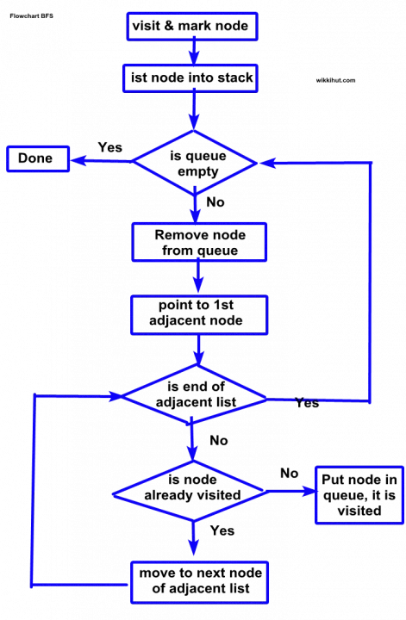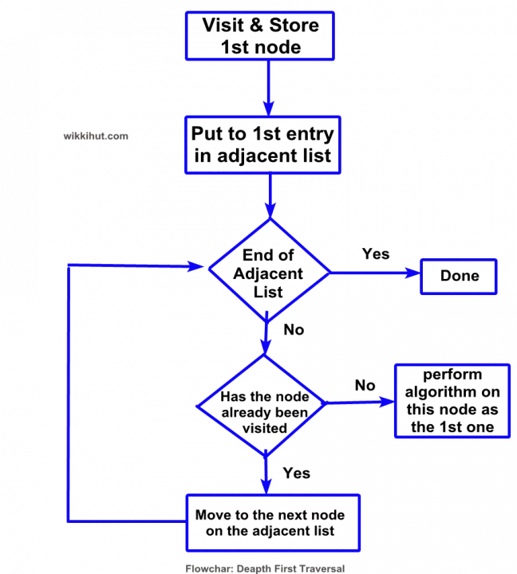

Result:
Thus, the BFS and DFS is successfully implemented and output is verified.

Aim:
12. Program to implement N Queens problem.

To write a Python program to implement N Queens problem

Algorithm:
  - Initialize an empty chessboard of size NxN.
  - Start with the leftmost column and place a queen in the first row of that column.
  - Move to the next column and place a queen in the first row of that column.
  - Repeat step 3 until either all N queens have been placed or it is impossible to place a queen in the current column without violating the rules of the problem.
  - If all N queens have been placed, print the solution.
  - If it is not possible to place a queen in the current column without violating the rules of the problem, backtrack to the previous column.
  - Remove the queen from the previous column and move it down one row.
  - Repeat steps 4-7 until all possible configurations have been tried.

Program:
def is_valid(board, row, col, n): # Check row on the left
for i in range(col):
if board[row][i] == 1: return False

# Check upper diagonal on the left
for i, j in zip(range(row, -1, -1), range(col, -1, -1)): if board[i][j] == 1:
return False

# Check lower diagonal on the left
for i, j in zip(range(row, n, 1), range(col, -1, -1)): if board[i][j] == 1:
return False return True
def n_queens_util(board, col, n, solutions): if col == n:
solution = []
for i in range(n): row = []
for j in range(n):
if board[i][j] == 1: row.append('Q')
else:
row.append('.')

solution.append(''.join(row)) solutions.append(solution) return

for i in range(n):
if is_valid(board, i, col, n): board[i][col] = 1
n_queens_util(board, col + 1, n, solutions) board[i][col] = 0

def n_queens(n):
board = [[0 for _ in range(n)] for _ in range(n)] solutions = []
n_queens_util(board, 0, n, solutions) return solutions

# Example usage n = 4
solutions = n_queens(n)
print(f"Number of solutions for {n} queens: {len(solutions)}") for i, solution in enumerate(solutions):
print(f"Solution {i+1}:") for row in solution:
print(row)

OUTPUT:
Number of solutions for 4 queens: 2 Solution 1:
.Q..
...Q
Q...
..Q.

Solution 2:
..Q.
Q...
...Q
.Q..

Result:
Thus, the N queens problem is successfully implemented and output is verified.

13. Program to implement Binary Tree Traversal
Aim:

To write a Python program to implement Binary Tree Traversal.

Algorithm:
Algorithm Inorder(tree)

    - Traverse the left subtree, i.e., call Inorder(left->subtree)
    - Visit the root.
    - Traverse the right subtree, i.e., call Inorder(right->subtree) Algorithm Preorder(tree)
- Visit the root.

- Traverse the left subtree, i.e., call Preorder(left->subtree)

- Traverse the right subtree, i.e., call Preorder(right->subtree) Algorithm Postorder(tree)
- Traverse the left subtree, i.e., call Postorder(left->subtree)

- Traverse the right subtree, i.e., call Postorder(right->subtree)

- Visit the root.

Program:
class Node:
def init (self, val=None): self.val = val
self.left = None self.right = None

def preorder_traversal(root): if root is None:
return print(root.val, end=' ')
preorder_traversal(root.left) preorder_traversal(root.right)

def inorder_traversal(root): if root is None:
return inorder_traversal(root.left) print(root.val, end=' ') inorder_traversal(root.right)

def postorder_traversal(root): if root is None:
return postorder_traversal(root.left)

postorder_traversal(root.right) print(root.val, end=' ')

def bfs_traversal(root): if root is None:
return queue = [root] while queue:
node = queue.pop(0) print(node.val, end=' ') if node.left:
queue.append(node.left) if node.right:
queue.append(node.right)

# Example usage root = Node(1) root.left = Node(2) root.right = Node(3) root.left.left = Node(4)
root.left.right = Node(5)

print("Preorder traversal:", end=' ') preorder_traversal(root)
print()

print("Inorder traversal:", end=' ') inorder_traversal(root)
print()

print("Postorder traversal:", end=' ') postorder_traversal(root)
print()

print("BFS traversal:", end=' ') bfs_traversal(root)
print()

Output:
Preorder traversal: 1 2 4 5 3
Inorder traversal: 4 2 5 1 3
Postorder traversal: 4 5 2 3 1
BFS traversal: 1 2 3 4 5

Result:
Thus, the Binary tree traversal is successfully implemented and output is verified.

14. Program to implement Travelling Salesman Problem

Aim:
To write a Python program to implement travelling salesman problem.

Algorithm:

- Consider city 1 as the starting and ending point. Since the route is cyclic, it can consider any point as a starting point.
- Generate all (n-1)! permutations of cities.
- Calculate the cost of every permutation and keep track of the minimum cost permutation.
- Return the permutation with minimum cost.

Program:

import networkx as nx
import matplotlib.pyplot as plt import itertools

# Generate a random graph of cities num_cities = 5
graph = nx.complete_graph(num_cities) for u, v in graph.edges():
graph[u][v]['weight'] = round(100 * (1 + u + v), 2)

# Find the shortest route that visits all cities and returns to the starting city shortest_route = None
shortest_length = float('inf')
for permutation in itertools.permutations(range(num_cities)):
length = sum(graph[u][v]['weight'] for u, v in zip(permutation, permutation[1:] + permutation[:1]))
if length < shortest_length: shortest_route = permutation shortest_length = length

# Print the shortest route and its length
print(“A complete graph of 5 cities with random weights”) print("Shortest route:", shortest_route)
print("Length:", shortest_length)

# Draw the graph with the shortest route highlighted pos = nx.spring_layout(graph)
nx.draw(graph, pos, with_labels=True)
nx.draw_networkx_edges(graph, pos, edgelist=[(shortest_route[i], shortest_route[i+1]) for i in range(num_cities-1)] + [(shortest_route[-1], shortest_route[0])], edge_color='r', width=2) plt.show()

Output:
A complete graph of 5 cities with random weights Shortest route: (0, 1, 2, 3, 4)
Length: 1115.0

Result:
Thus, the travelling salesman problem is successfully implemented and output is verified.

